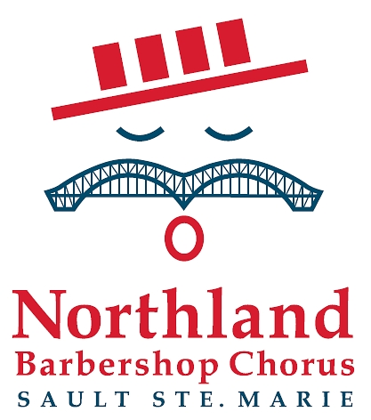
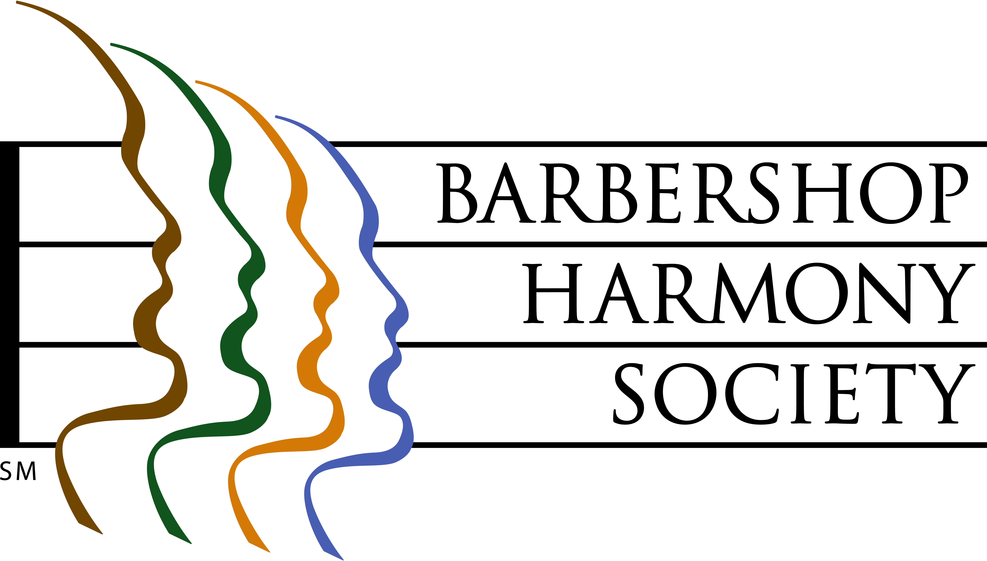

A Brief History of the Northland Barbershop Chorus

The Northland Barbershop Chorus is the Sault Ste. Marie Chapter of The Barbershop Harmony Society, the world’s largest men’s singing organization. It is one of 800+ chapters serving 25,000+ members across North America. Affiliated barbershop singing organizations span much of the world.

Locally, four men met in 1959 to discuss the formation of a chapter and to sing four-part harmony in the style of the traditional barbershop quartet. Harry Shardlow, Frank Elliott, Ted Spry and Len Klyne, began quarteting as the Border Chorders which eventually gave rise to today’s chorus. In that time, hundreds of men have enjoyed the thrill of a cappella singing, while entertaining thousands of Sault and area residents. Membership in the Chorus is often affectionately called a “voluntary life sentence” by its members, reflecting their love of the music and the bond of brotherhood they feel.

By 1961, the group had expanded to 26 members and on Dec. 1, 1961 received their official charter to become the Sault Chapter of SPEBSQSA - The Society for the Preservation and Encouragement of Barbershop Quartet Singing in America, Inc. – now the Barbershop Harmony Society. Their first performance was in 1962 and a major show has been presented annually since then. In 2011, the Chorus celebrated its 50th season. In addition to a major annual spring show, the Chorus also typically gives 10-15 community performances each year.

The Northland Chorus is a not-for-profit, incorporated organization comprised 100% of volunteers devoted to fostering and promoting music sung in the barbershop style: 4-part harmony with the melody in the second voice, sung without musical accompaniment. They seek to serve their communities in two ways:
- through the medium of song by singing at no cost at senior's homes, schools, churches, hospitals, civic events; or at fund-raising events held in support of a various local charitable and arts organizations, and
- through their annual support of the Speech Language Pathology Unit at Sault Area Hospital, to whom they have donated in excess of $101,000 (as of their 2019 show) since 1995 in keeping with their motto: “We Sing ...That They Shall Speak”. These funds assist those for whom stroke, cancer, head injury or other ailments have robbed the ability to communicate.
Beginning in 2009, the Chorus (many of whose members reside on the U.S. side) expanded their efforts to include annual donations to the Speech Pathology Department at War Memorial Hospital in Sault Michigan.
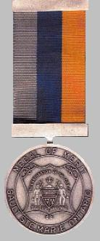

In recognition of community service given over 5 decades, the City of Sault Ste Marie Ontario awarded the Northland Barbershop Chorus the 2010 Medal of Merit, the city’s most prestigious honor. The award is given annually for “outstanding achievement in a chosen area which has resulted in making a valuable contribution to the community”. The award was officially presented to all then currently active chorus members by Mayor Debbie Amoroso at a civic ceremony and dinner held May 7, 2011.
The Barbershop Style

Barbershop style singing originated in the U.S. between 1890 and the 1920s, and was revived beginning in 1938 with the formation of “The Society for the Preservation and Encouragement of Barbershop Quartet Singing in America” in Tulsa, Oklahoma. Starting as an all-male quartet style, barbershop has expanded beyond the quartet and is now sung in choruses of all sizes as well as by all-women and mixed-voice quartets and choruses. Barbershop always has four parts: tenor, lead, baritone & bass. There are well-defined rules about what is and isn’t barbershop; songs chosen to be sung in this style generally have easy-to-sing melodies, wholesome themes and heart-felt emotions.

The hallmark of the style is 4-part harmony arranged such that the melody is surrounded above and below by the three harmony parts. It is sung unaccompanied by musical instruments. The lead sings the melody with the tenor singing above him and the bass below. The baritone sings a compromise part unique to barbershop, sometimes above the lead and sometimes below. Placing the melody in a middle voice as opposed to either the top or the bottom of the chord is what distinguishes barbershop from other forms of vocal harmony. From the highest tenor to the lowest bass, man or woman, the style offers everyone the opportunity to sing, whatever their vocal range.

Many different types of music are adaptable to the barbershop style, from traditional hymns and southern gospel through to doo-wop, swing and show tunes. While choruses typically mix popular songs into their repertoire, the style is often associated with songs from an earlier era, when songwriters tended to write lyrics that told a story, set to melodies that invited harmony, and sung from the heart. These familiar songs were mostly written between 1900 and 1960. Many popular songs written since then have been successfully adapted to be sung in the barbershop style.

Sing With The Northland Chorus!

The chorus membership currently stands at 40 men. Are you No. 41?

All men who love to sing are always welcome to drop in to a Chapter meeting. The Chapter meets every Monday evening from the 1st Monday after Labour Day until late June from 7:00 to 9:30 p.m. at the Salvation Army Hall at 670 John Street. No meetings are held in July or August. The ability to read music, while helpful, is not mandatory. They will teach you. The only requirements are the ability and desire to sing.

For more information, call Chorus Director Bob Shami at 705-253-9574.

Bob Shami, 14-Jan-23
Music Director & Chapter Treasurer
Northland Barbershop Chorus
Sault Ste. Marie Chapter, Barbershop Harmony Society
Society Member Since 1983
H: 705-253-9574
bshami@northlandchorus.com

